Lab Assignment #1
Cryptography

Steffen L. Norgren <ironix@trollop.org>
A00683006

COMP 7615 • BCIT • September 20, 2009

Table of Contents

Purpose 3
Procedures 3
Texts Used 3
Unencrypted Text #1 Frequency 4
Unencrypted Text #2 Frequency 5
Unencrypted Text #3 Frequency 6
Frequency Table 7
Encrypted Text #1 Frequencies 8
Encrypted Text #2 Frequencies 8
Encrypted Text #3 Frequencies 10
Discussion 11
Conclusion 11

Purpose
The English language has a predictable structure in letter usage, which means that encryption using a simple letter substitution is not very secure. One can easily do a brute-force decryption of such texts by doing a frequency analysis.
As such, the purpose of this lab is to show that the Caesar cipher, a simple shifting cipher, can be easily broken by doing a simple frequency analysis of the most commonly occurring letter.

Procedures

Texts Used
- Text #1 – Astounding Stories of Super-Science, February 1930:
http://www.gutenberg.org/ebooks/28617
- Text #2 – Astounding Stories of Super-Science, March 1930:
http://www.gutenberg.org/ebooks/29607
- Text #3 – Astounding Stories of Super-Science, April 1930:
http://www.gutenberg.org/ebooks/29390

Unencrypted Text #1 Frequency
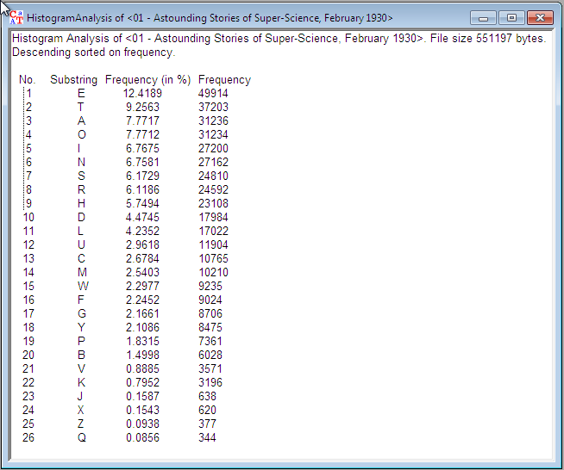

Unencrypted Text #2 Frequency
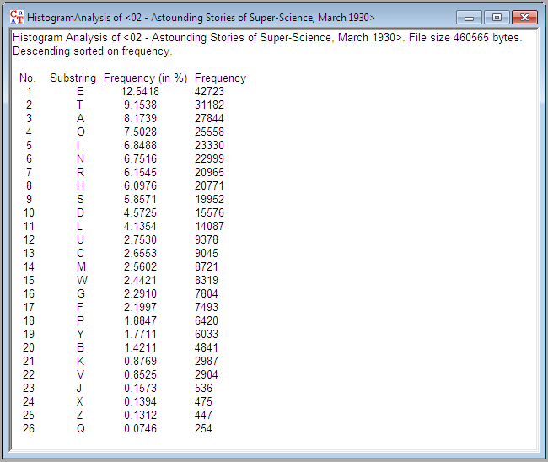

Unencrypted Text #3 Frequency
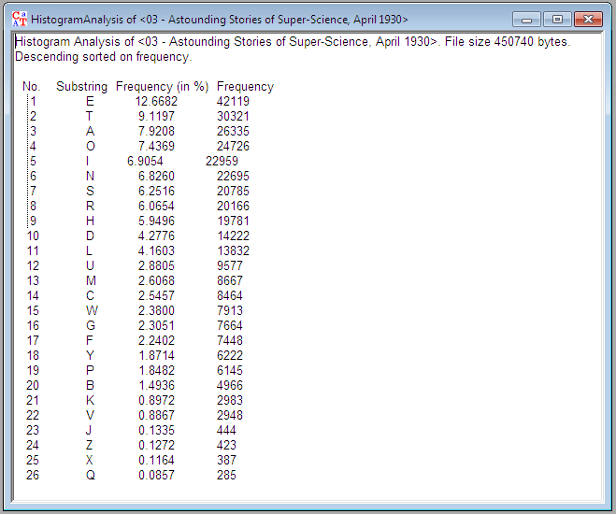

Frequency Table
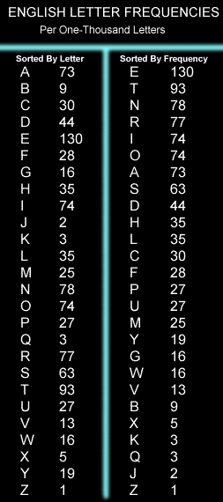

Encrypted Text #1 Frequencies
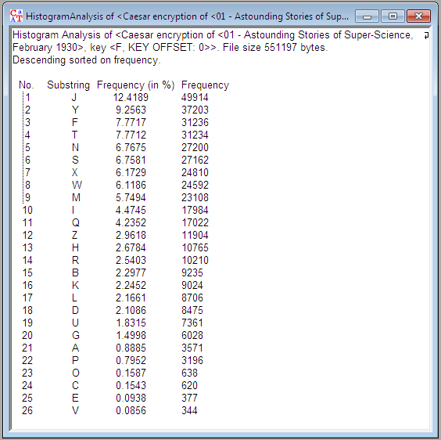

Encrypted Text #2 Frequencies
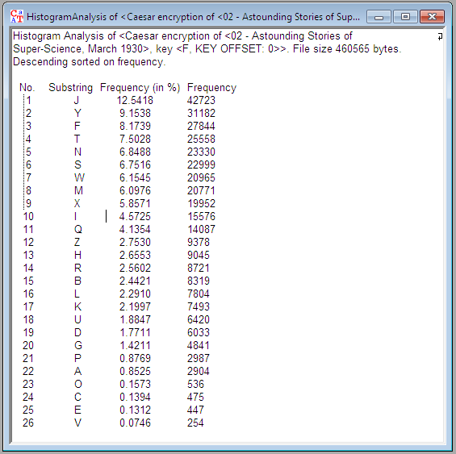

Encrypted Text #3 Frequencies
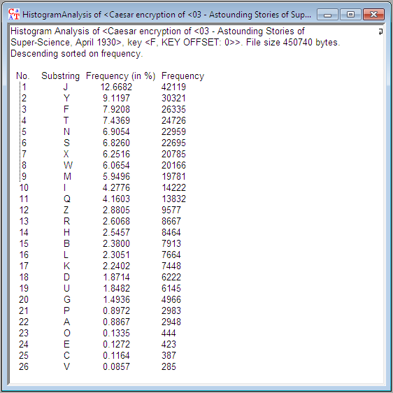

Discussion
The first thing I noticed while doing frequency analyses of the text was that these particular texts did not follow the normal frequency distribution exactly. The first two letters, E and T, did follow the example distribution, but after that I saw many differences between the text's frequency distribution and the example.
The encrypted frequencies look quite a bit different from the unencrypted frequencies, but this is expected.

Conclusion
As a result of performing the above frequency analysis on unencrypted and encrypted texts, we can make the assumption that the first two letters in each frequency analysis will always correspond to each other.
What this means is that we can easily decrypt the encrypted texts by doing a frequency analysis of the letters contained therein. With such results, we would simply need to shift the letters over. For example, if the most common letter in the encrypted version was an O, we would simply need to count the separation between O and E and then shift all letters in the text by that amount.

